Homework 1 - Basic Networking Utilities
- This is an individual assignment, and worth 20 points.
- The due date and time is Wednesday, September 15th, Midnight.
- You need to provide your outcomes to the “Homework 1-Outcome.docx.” Change the file name following the naming convention. The naming convention is as follows: homework, hypen, last name, first initial, and extension (e.g., Homework1-ImG.docx). If you do not follow the convention, I will deduct 1.
- Make screenshots small so that you can save space.

Tasks
(Task 1) Provide a screenshot #1. 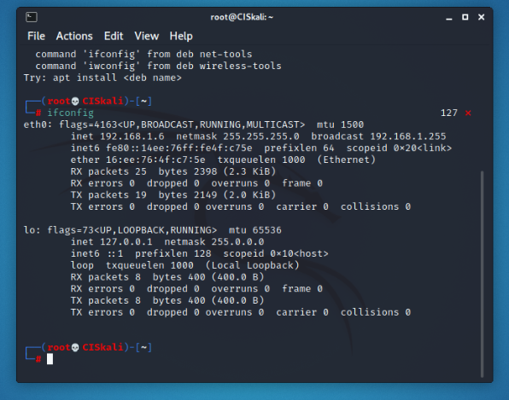

(Task 2) Provide a screenshot #2.
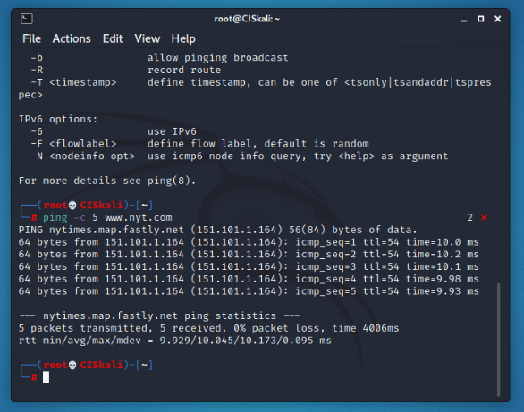
(Task 3) Provide a screenshot #3.
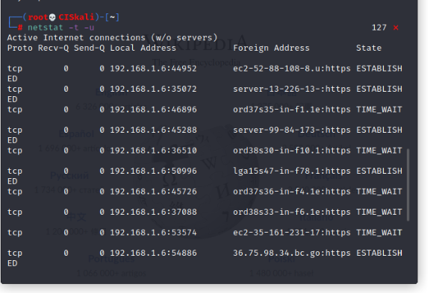
(Task 4) Provide a screenshot #4.
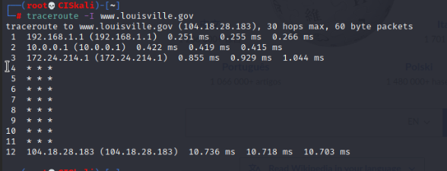
(Task 5) Provide a screenshot #5.
