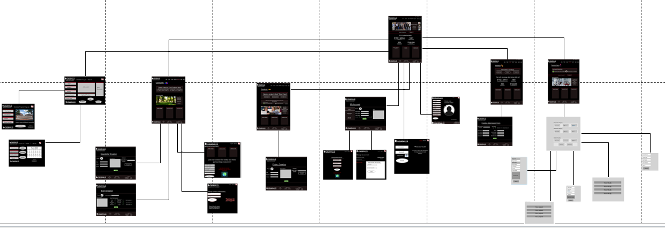
This Screen Layout Shows The main home page and every destination that the user can make from the main homepage. The screen layout shows each and every use case that is needed for the website to function. Use cases such as the log in page, sign in page, Newsletter sign up, and every other use case are all realized into their own prototypes to show how they could look like, what the user will see and what they will need to enter into the text boxes to complete the main flow of the use cases we built in assignment 3.

